['label' => 'About', 'url' => ['/site/about']],

],

]);

8. Try to open the content page. The filter must redirect you to the agreement page:

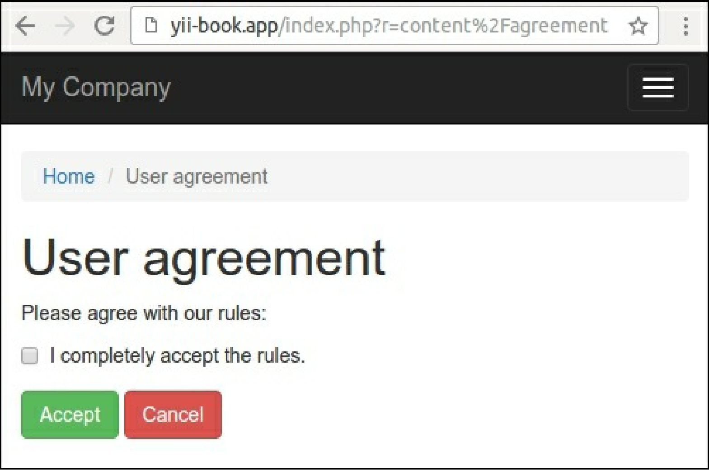

9. Only after accepting the rules can you see the private content:

